The BiGy Players Tercie B

present
A Treasure
in the Sargasso Sea
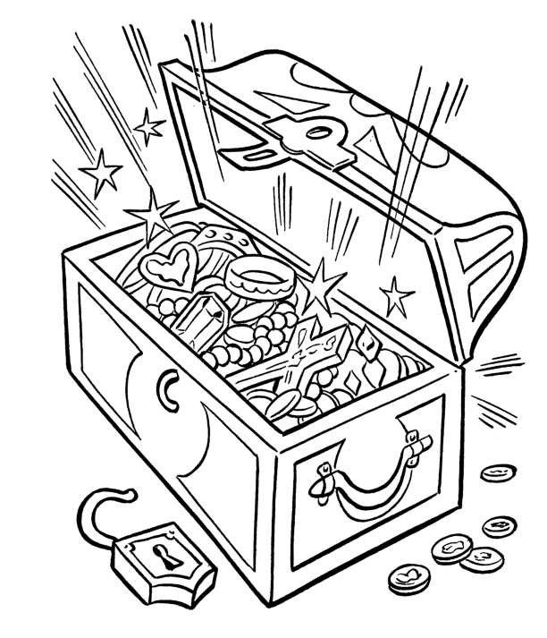

Come with us on an adventurous journey seeking treasure. You will experience the kidnapping of a prince, you will meet bloodthirsty natives and cutthroat pirates. As in every fairy tale there is a happy ending.
Premiere!

The Barka Theatre
Monday March 30, 2015 at 7 pm

